CYBR 1500 Assignment, Week 10+11

# Part I: Required Readings and Lecture Content

* Watch the videos here for the lectures.

Video Lecture 1, Week 10+11 Update: <https://youtu.be/rn8BpEDOYEE>

Video Lecture 2, Chapter 14, part 1: <https://youtu.be/qc3okz3lNH0>

Video Lecture 3, Chapter 14, part 2: <https://youtu.be/L45EpGJwI7U>

* Read and be familiar with chapter 14 of Blum & Bresnahan.

# Part 2: Chapter 14, User Input (1)

Type in and run the following scripts from the text, chapter 14:

**test1(page.366):**

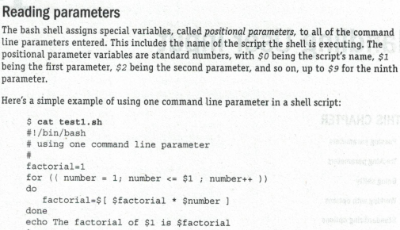

**Output of test1:**



**test15(p.377):**

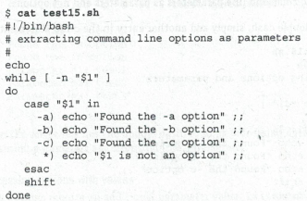

**Output of test15:**

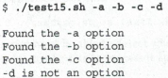

Use the cat command to display content of all two scripts, run all two scripts, and capture that part of the terminal interactions below.

>>>>>Paste your terminal capture below this line >>>>>

**andrew@andrew-VirtualBox**:**~/hwscripts**$ cat test1.sh

#!/bin/bash

factorial=1

for (( number = 1; number <=$1 ; number++ ))

do

    factorial=$[$factorial * $number]

done

echo The factorial $1 is $factorial

**andrew@andrew-VirtualBox**:**~/hwscripts**$ ./test1.sh 5

The factorial 5 is 120

**andrew@andrew-VirtualBox**:**~/hwscripts**$ cat test15.sh

#!/bin/bash

echo

while [ -n "$1" ]

do

    case "$1" in

-a) echo "Found the -a option" ;;

-b) echo "Found the -b option" ;;

-c) echo "Found the -c option" ;;

-d) echo "Found the -d option" ;;

    esac

    shift

done

**andrew@andrew-VirtualBox**:**~/hwscripts**$ ./test15.sh -a -b -c -d

Found the -a option

Found the -b option

Found the -c option

Found the -d option

<<<<< Paste your terminal capture above this line <<<<<

# Part 3: Chapter 14, User Input (2)

Create a script file that will display the script name, the first three user’s inputs. The script not only calculates the product and sum of the first two inputs but also calculate the factorial of the third input. Below is the sample when you run the script:



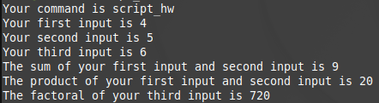The output should be:

Capture these terminal interactions below.

>>>>>Paste your terminal capture below this line >>>>>

**andrew@andrew-VirtualBox**:**~/hwscripts**$ cat scripthw

#!/bin/bash

echo Your command is $filename

echo Your first input is $1

echo Your second input is $2

echo Your third input is $3

sum=$[ $1 + $2 ]

product=$[ $1 * $2]

factorial=1

for (( number = 1; number <= $3; number++ ))

do

    factorial=$[ $factorial * $number ]

done

echo The sum of your first input and second input is $sum

echo The product of your first input and second input is $product

echo The factorial of your third input is $factorial

**andrew@andrew-VirtualBox**:**~/hwscripts**$ ./scripthw 4 5 6

Your command is

Your first input is 4

Your second input is 5

Your third input is 6

The sum of your first input and second input is 9

The product of your first input and second input is 20

The factorial of your third input is 720

**andrew@andrew-VirtualBox**:**~/hwscripts**$ ^C

**andrew@andrew-VirtualBox**:**~/hwscripts**$

<<<<< Paste your terminal capture above this line <<<<<

# Part 4: Submit your assignment to Blackboard

***NB. Don’t forget to take the weekly quiz!***

# Rubric: 60 points

* Part 2: test1, test15, 30 points (15 points each)
* Part 3: script, 30 points
  + Accurate output, 15 points;
  + Follows instructions, 15 points.

Maximum of 2 points deduction per mistake due to grader’s judgement.